DPV INTERNATIONAL

AI-Powered Overseas Lead Generation System
Implementation Proposal for Multi-Platform Lead Discovery, Qualification and Conversion
8 Weeks  Initial Delivery | Week 2  Prototype Demo | Week 5  Live Pilot | Week 8  Acceptance

Item | Details
Prepared for | DPV International Management and Business Teams
Version | V1.0
Date | August 2026
Classification | Internal Proposal

Contents
- 1. Executive Summary
- 2. Business Context and Overseas Target Buyers
- 3. Overseas Lead Source Strategy
- 4. Automated Lead Generation Workflow
- 5. System Architecture
- 6. Lead Scoring and Qualification Tiers
- 7. Company Data Requirements
- 8. Eight-Week Implementation Plan
- 9. Automation Roadmap
- 10. Acceptance Metrics and Risk Controls
- Appendices

1. Executive Summary
This proposal establishes an overseas lead generation system for DPV International, combining multi-platform company discovery, data enrichment, lead scoring, product-to-buyer matching, multilingual outreach and conversion feedback. The primary targets are qualified business buyers; consumer and social-content signals are used to assess market demand rather than to replace business qualification.
The initial delivery spans eight weeks. A demonstrable prototype will be available in Week 2, the multi-source lead database MVP will be completed in Week 4, live outreach will begin in Week 5 and acceptance will be completed in Week 8. Human approval remains mandatory during the initial phase, with controlled automation introduced only after data quality and operating performance are proven.
Primary outcome: a closed operating loop covering discovery, verification, scoring, product matching, approval, outreach, sales follow-up and conversion feedback.

2. Business Context and Overseas Target Buyers
DPV International is positioned as a bulk export supplier across women's, men's and children's apparel, bags, beauty products and household goods. Its operating footprint across Guangzhou, Hong Kong and India provides a foundation for sourcing and export coordination. The corporate website documents flexible MOQs, wholesale enquiries, FOB/CIF quotation practices and export-ready packing, and will serve as the system's company and product knowledge source.
Mexico will provide the baseline for proven buyer profiles, product demand and outreach language. The United Arab Emirates will be the first new-market pilot, focusing on Dubai-based importers, regional wholesalers, retail buyers and e-commerce operators. Bangladesh will follow as the second expansion market, with buyer segments and product emphasis adjusted to validated commercial data.

2.1 Target Buyer Segments
- Importers and regional distributors of apparel, bags and household goods
- Wholesalers, retail chains, department stores and specialist retail buyers
- Business sellers operating on Amazon, Noon, Mercado Libre and similar marketplaces
- Private-label brands, OEM buyers and sourcing agencies
- Trading companies and corporate purchasing teams with recurring replenishment demand

2.2 Qualification Boundaries
Individual consumers, social accounts without a verifiable business entity, companies with no relevant commercial fit, duplicates, opted-out contacts and unverifiable contact records will not enter the active outreach pool.

3. Overseas Lead Source Strategy
Overseas platforms are combined across five roles: company discovery, buying signals, contact enrichment, content trends and inbound lead capture. No single platform is treated as a complete source of truth.
Source Type | Representative Channels | Primary Purpose | Initial Integration
Search & Maps | Google, Google Maps, Bing | Identify target-market companies, websites and coverage | Search/API and public-page parsing
Professional Networks | LinkedIn | Identify companies, buyers and relevant job titles | Research tasks and human outreach
Social Platforms | Facebook, Instagram | Discover business pages, groups, ads and enquiries | Public signals and owned-account data
Video & Content | TikTok, YouTube | Identify brands, sellers, trends and content momentum | Official APIs and public metadata
B2B Marketplaces | Alibaba, Global Sources, TradeKey | Discover buyers, enquiries and category demand | Platform-authorized export or API
Trade Data & Directories | ImportGenius, Panjiva, Kompass | Validate import activity, business identity and buying capacity | Corporate accounts or public data
Events & Marketplaces | Trade shows, Amazon, Noon, Mercado Libre | Find exhibitors, brands and business sellers | List parsing and entity matching

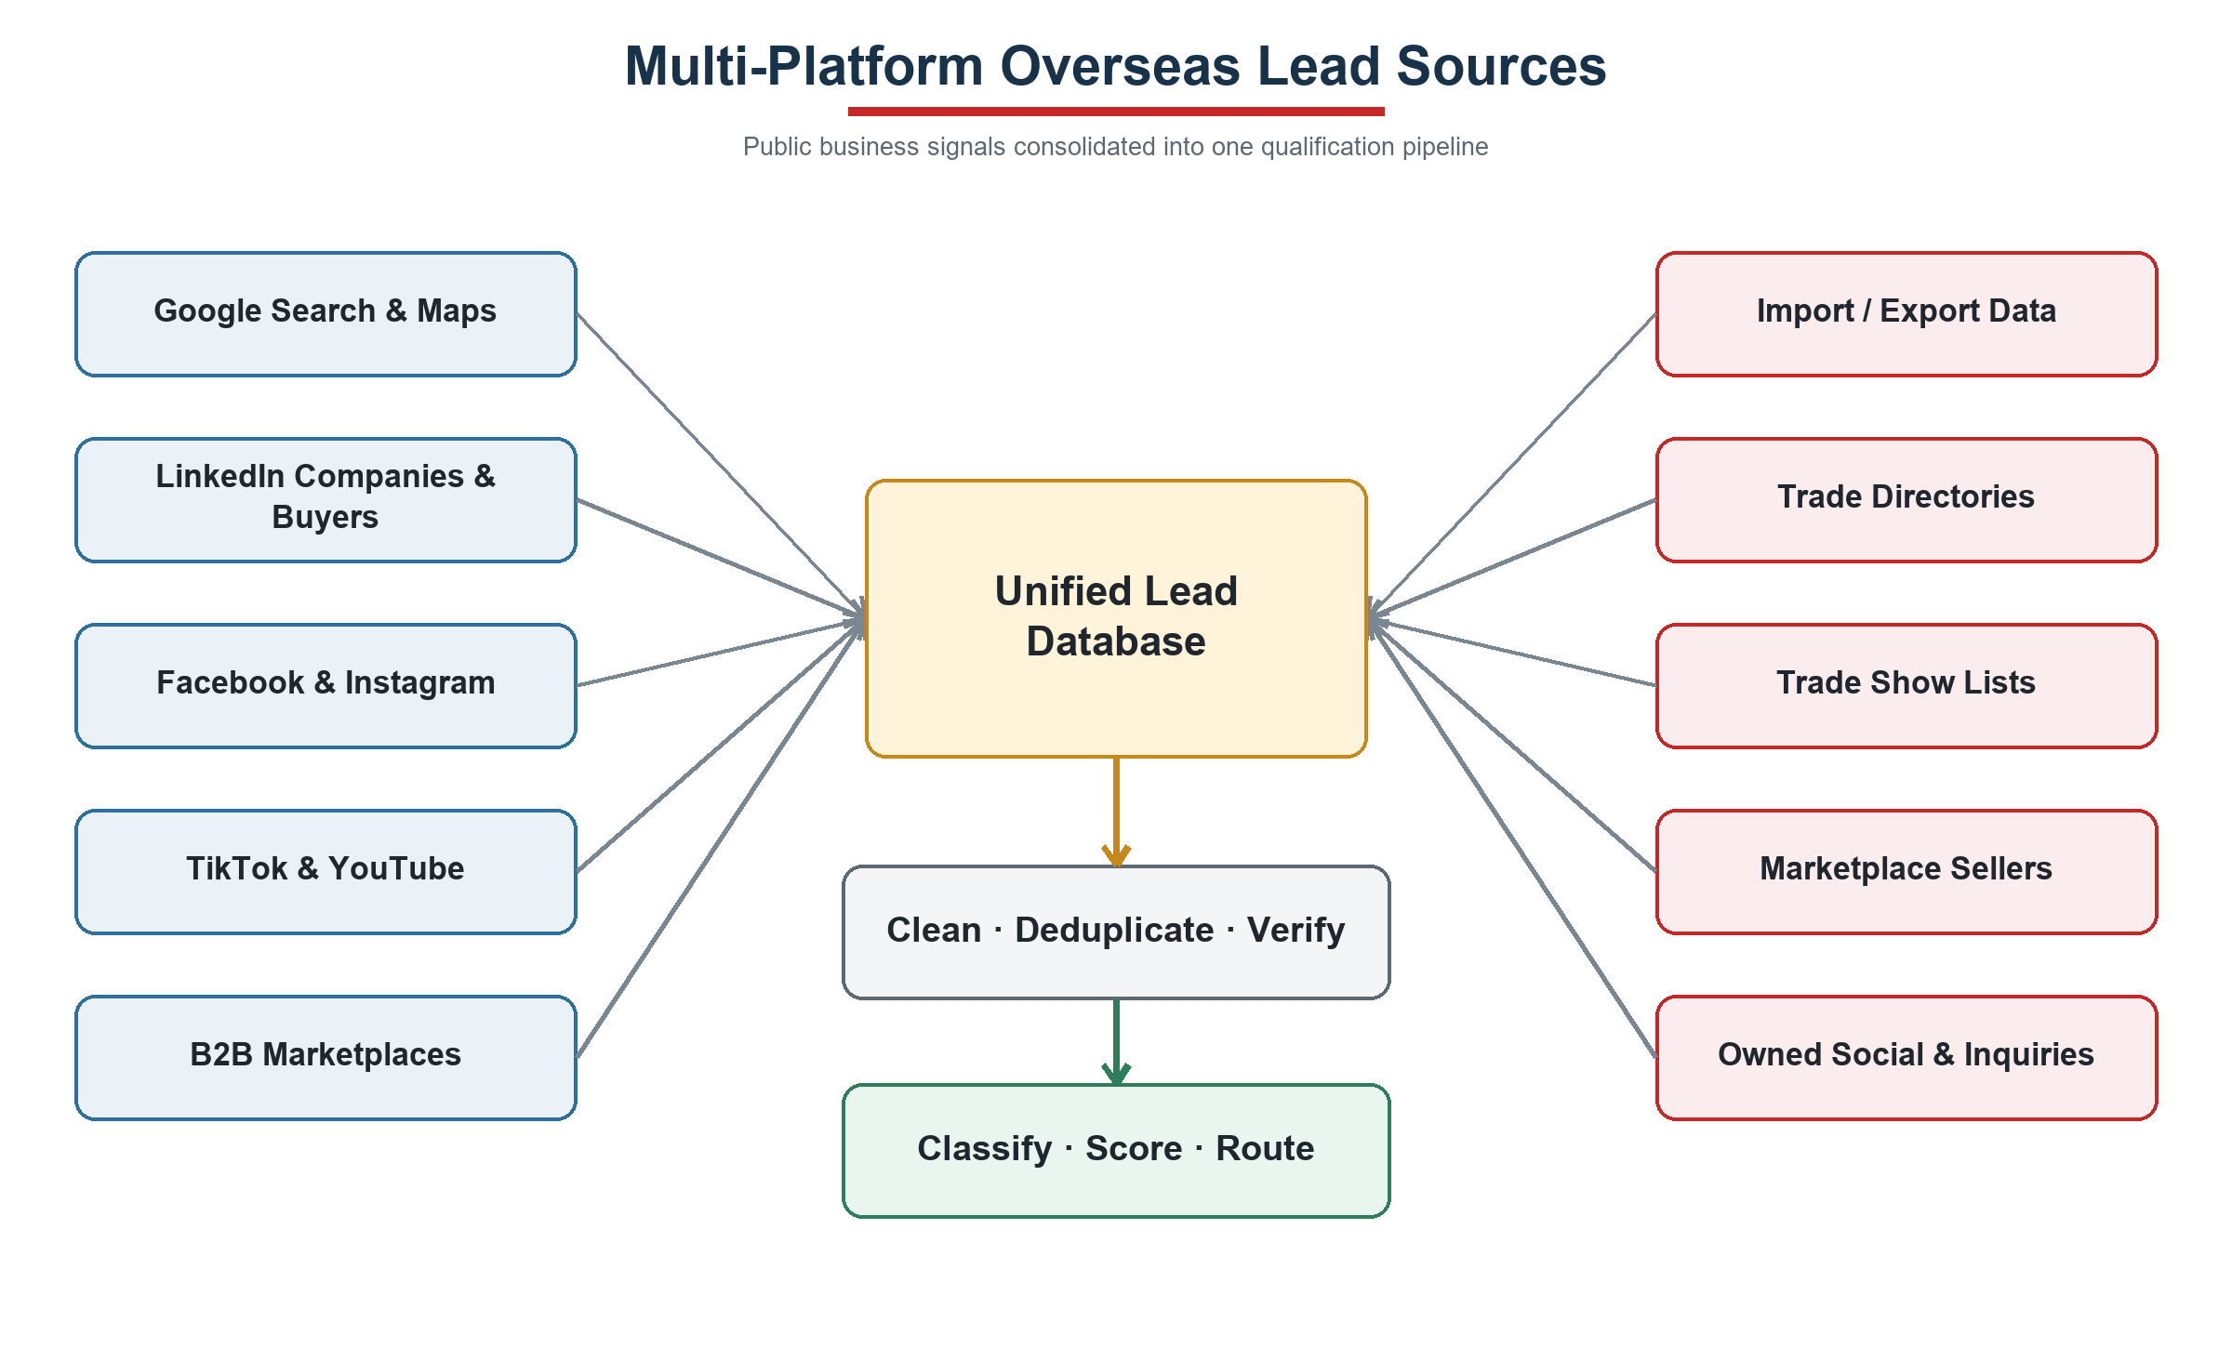
Figure 1. Multi-Platform Overseas Lead Sources
Platform signals are consolidated into unified company records before cleaning, deduplication, verification and qualification.

4. Automated Lead Generation Workflow
The system generates search strategies by market, city, product, buyer type and language, then acquires public business signals on a scheduled basis. Every candidate record retains its source URL, capture date and platform type before standardization, deduplication, contact verification, buyer classification and product matching.
Tier A leads receive personalized email drafts, LinkedIn contact tasks and product recommendations. All outbound content requires sales approval during the initial phase. Follow-up stops immediately after a reply, opt-out, hard bounce or manual takeover. Replies are classified into quotation, catalogue, sample, defer, decline or irrelevant categories and routed to the appropriate sales action.
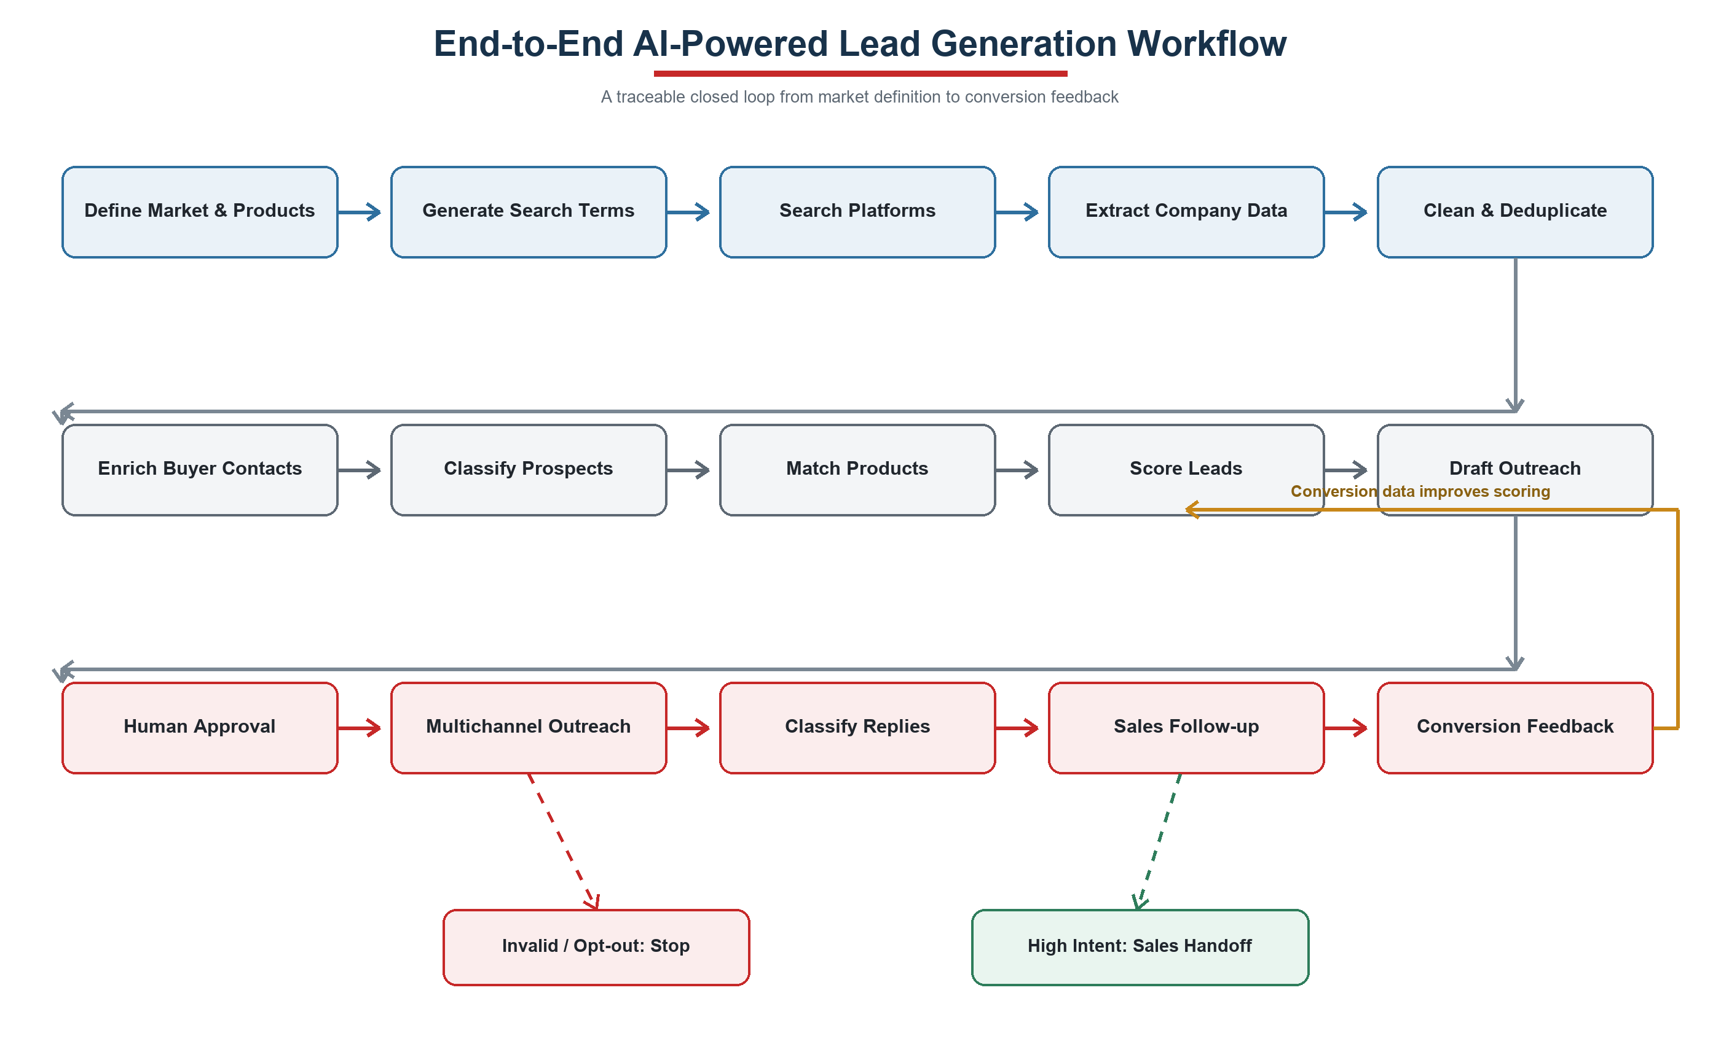
Figure 2. End-to-End AI-Powered Lead Generation Workflow
The workflow includes controls for invalid records, opt-outs, high-intent sales handoff and conversion feedback.

5. System Architecture
The solution uses a layered architecture built around n8n orchestration, a PostgreSQL data foundation, a CRM operating interface and large-language-model services. n8n manages scheduling, API integrations, approvals, alerts and write-back. PostgreSQL stores leads, products, campaigns, interactions, opt-outs and audit records. An existing CRM will be integrated where available; otherwise, NocoDB will provide the initial sales interface.
Language models support company classification, web-page summarization, product matching, multilingual copy and reply-intent detection. They do not independently determine prices, payment terms, contract terms or delivery commitments. Credentials are stored through controlled secrets management and all outbound actions are logged.

5.1 Layered Architecture
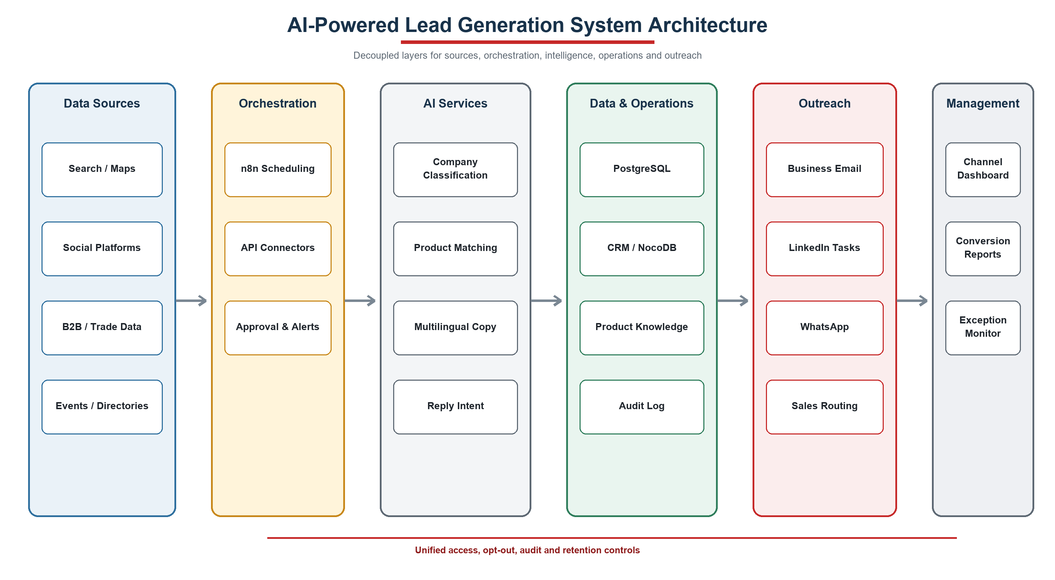
Figure 3. AI-Powered Lead Generation System Architecture
Standard interfaces allow individual platforms or model services to be replaced without changing the core data model.

6. Lead Scoring and Qualification Tiers
Scoring Dimension | Weight | Evidence
Product Fit | 20 | Category, price band, MOQ and buying use case
Market Fit | 15 | Country, city and geographic coverage
Buyer Type | 15 | Importer, wholesaler, retailer or business seller
Import / Wholesale Evidence | 15 | Trade records, wholesale positioning, stores or channel coverage
Company Scale | 10 | Stores, employees, revenue or operating-scale signals
Recent Buying Signal | 10 | New ranges, recruitment, events, content or import activity
Decision-Maker Quality | 10 | Role relevance and profile completeness
Contact Validity | 5 | Verified work email, business phone or approved channel

Tier A: 75–100; Tier B: 55–74; Tier C: below 55. Scores of 85 or above become eligible for automated first-touch only after the system is stable and send controls are satisfied.

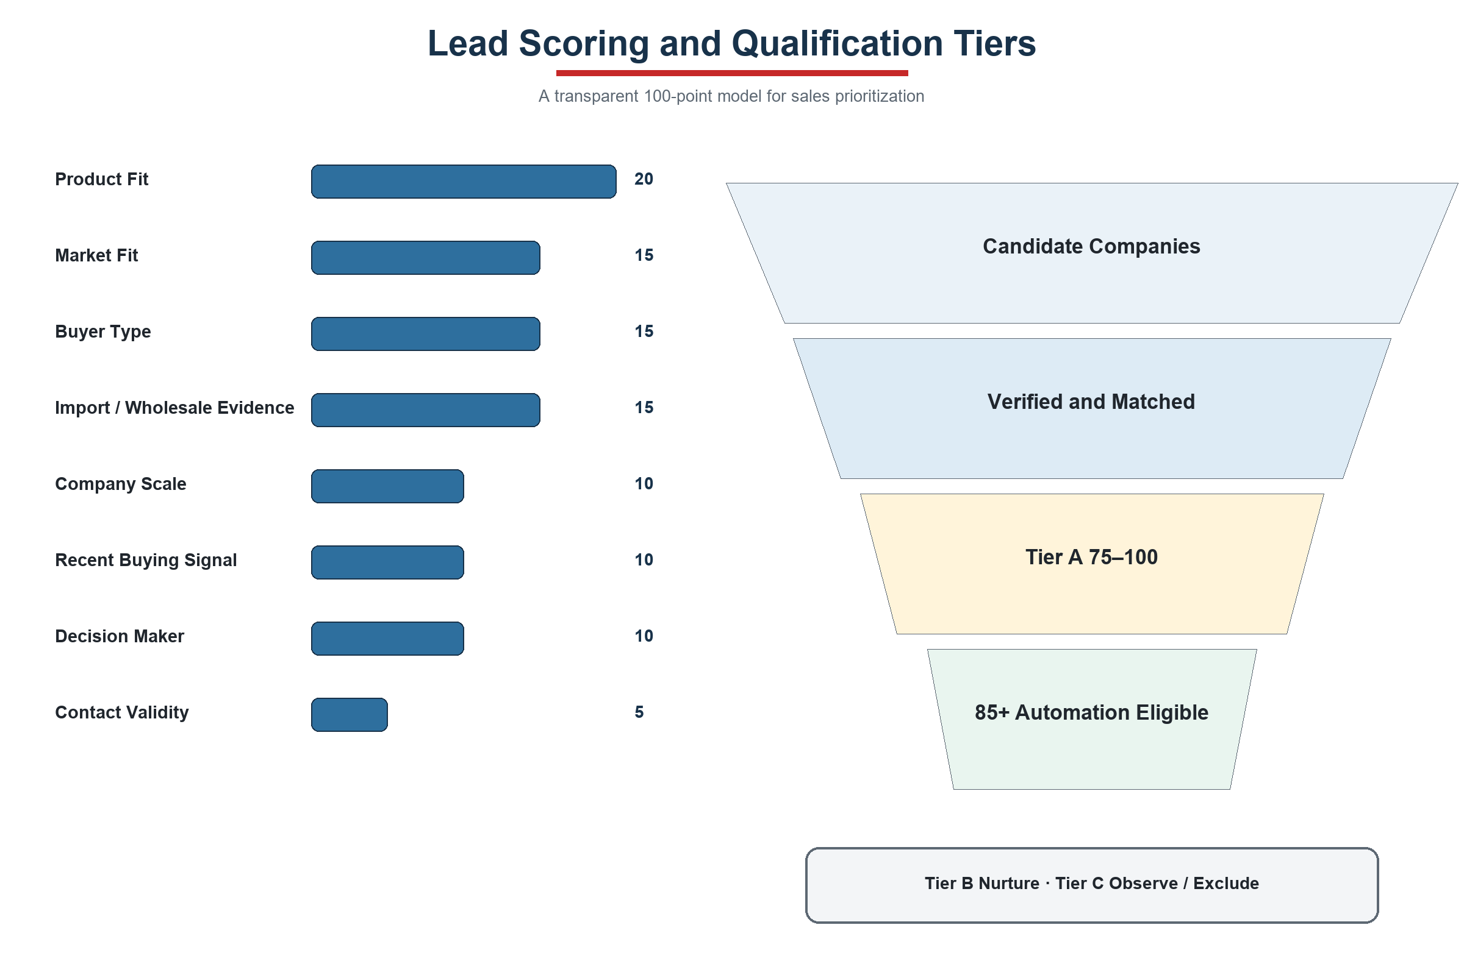
Figure 4. Lead Scoring and Qualification Tiers
Every score retains reason codes and source evidence so sales teams can review and explain the result.

7. Company Data Requirements
HR coordinates the request across management, sales, export operations, product, supply chain, finance and IT. The first submission consists of de-identified samples, field definitions and an account inventory; individual passwords are not transferred.
Priority | Data Package | Required Content | Coverage | Owner
P0 | Business Objectives | Target markets, buyer types, priority categories, lead/conversion goals, budget and exclusions | One-page management brief | Management
P0 | Historical Customers & Orders | Company, country, source, SKU, quantity, revenue, margin band, repeat orders and sales cycle | Past 12–24 months | Sales / Finance
P0 | Historical Lead Funnel | Source, contact, outreach, reply, quotation, conversion, stage and loss reason | 50 wins and 100+ losses/leads | Sales / Export
P0 | Product Master | SKU, material, size, MOQ, price tiers, FOB/CIF, samples, lead time, capacity, packing, certification and assets | 30–50 priority apparel SKUs | Product / Supply Chain
P0 | Sales Knowledge | Company profile, FAQs, quotation templates, successful copy, objections and prohibited claims | 20+ successful conversations | Sales / Management
P0 | Systems & Accounts | CRM, ERP, Excel, email, WhatsApp, social platforms, B2B platforms, APIs and owners | Complete inventory | IT / Administration
P1 | Channel Data | Website and WhatsApp enquiries, social engagement, advertising, events and platform exports | Past 6–12 months | Marketing / Sales
P1 | Supply & Fulfilment | Categories, capacity, lead times, ports, certifications, complaints and restrictions by operating location | By entity and category | Supply Chain / Factories
P1 | Governance Rules | Approvers, lead assignment, suppression list, retention, send limits and exception handling | Current policies | Management / IT

7.1 Initial Sample Size
- At least 50 converted customers and 100 non-converted leads.
- 30–50 priority SKUs and at least 20 successful sales conversations.
- An initial pool of 200–500 candidate companies and approximately 100 live outreach records.

8. Eight-Week Implementation Plan
Phase | Timing | Primary Activities | Deliverables | Acceptance Gate
1 Requirements & Data | Week 1 | Interviews, data samples, product and market confirmation | Data register, ICP and system inventory | Scope and fields approved
2 Rapid Prototype | Week 2 | Database, n8n and first search workflow | 50 sample leads | Prototype demonstration
3 Multi-Source MVP | Weeks 3–4 | Acquisition, cleaning, deduplication and verification | Unified pool of 200–500 leads | MVP completed
4 Classification & Matching | Weeks 4–5 | Classification, scoring, matching and multilingual copy | A/B/C tiers and drafts | Accuracy sample passed
5 Approval & Live Outreach | Week 5 | Human approval, sending, reply monitoring and stop rules | Approximately 100 live contacts | Pilot launched
6 Social Signals & Dashboard | Week 6 | Social signals, enquiry intake and channel reporting | Management dashboard and alerts | Full traceability
7 Optimize & Replicate | Week 7 | Optimize from pilot results and copy to second market | Bangladesh workflow | Rules reviewed
8 Acceptance & Handover | Week 8 | Testing, training, documentation and access review | System, guide and acceptance report | Initial acceptance

8.1 Project Roadmap
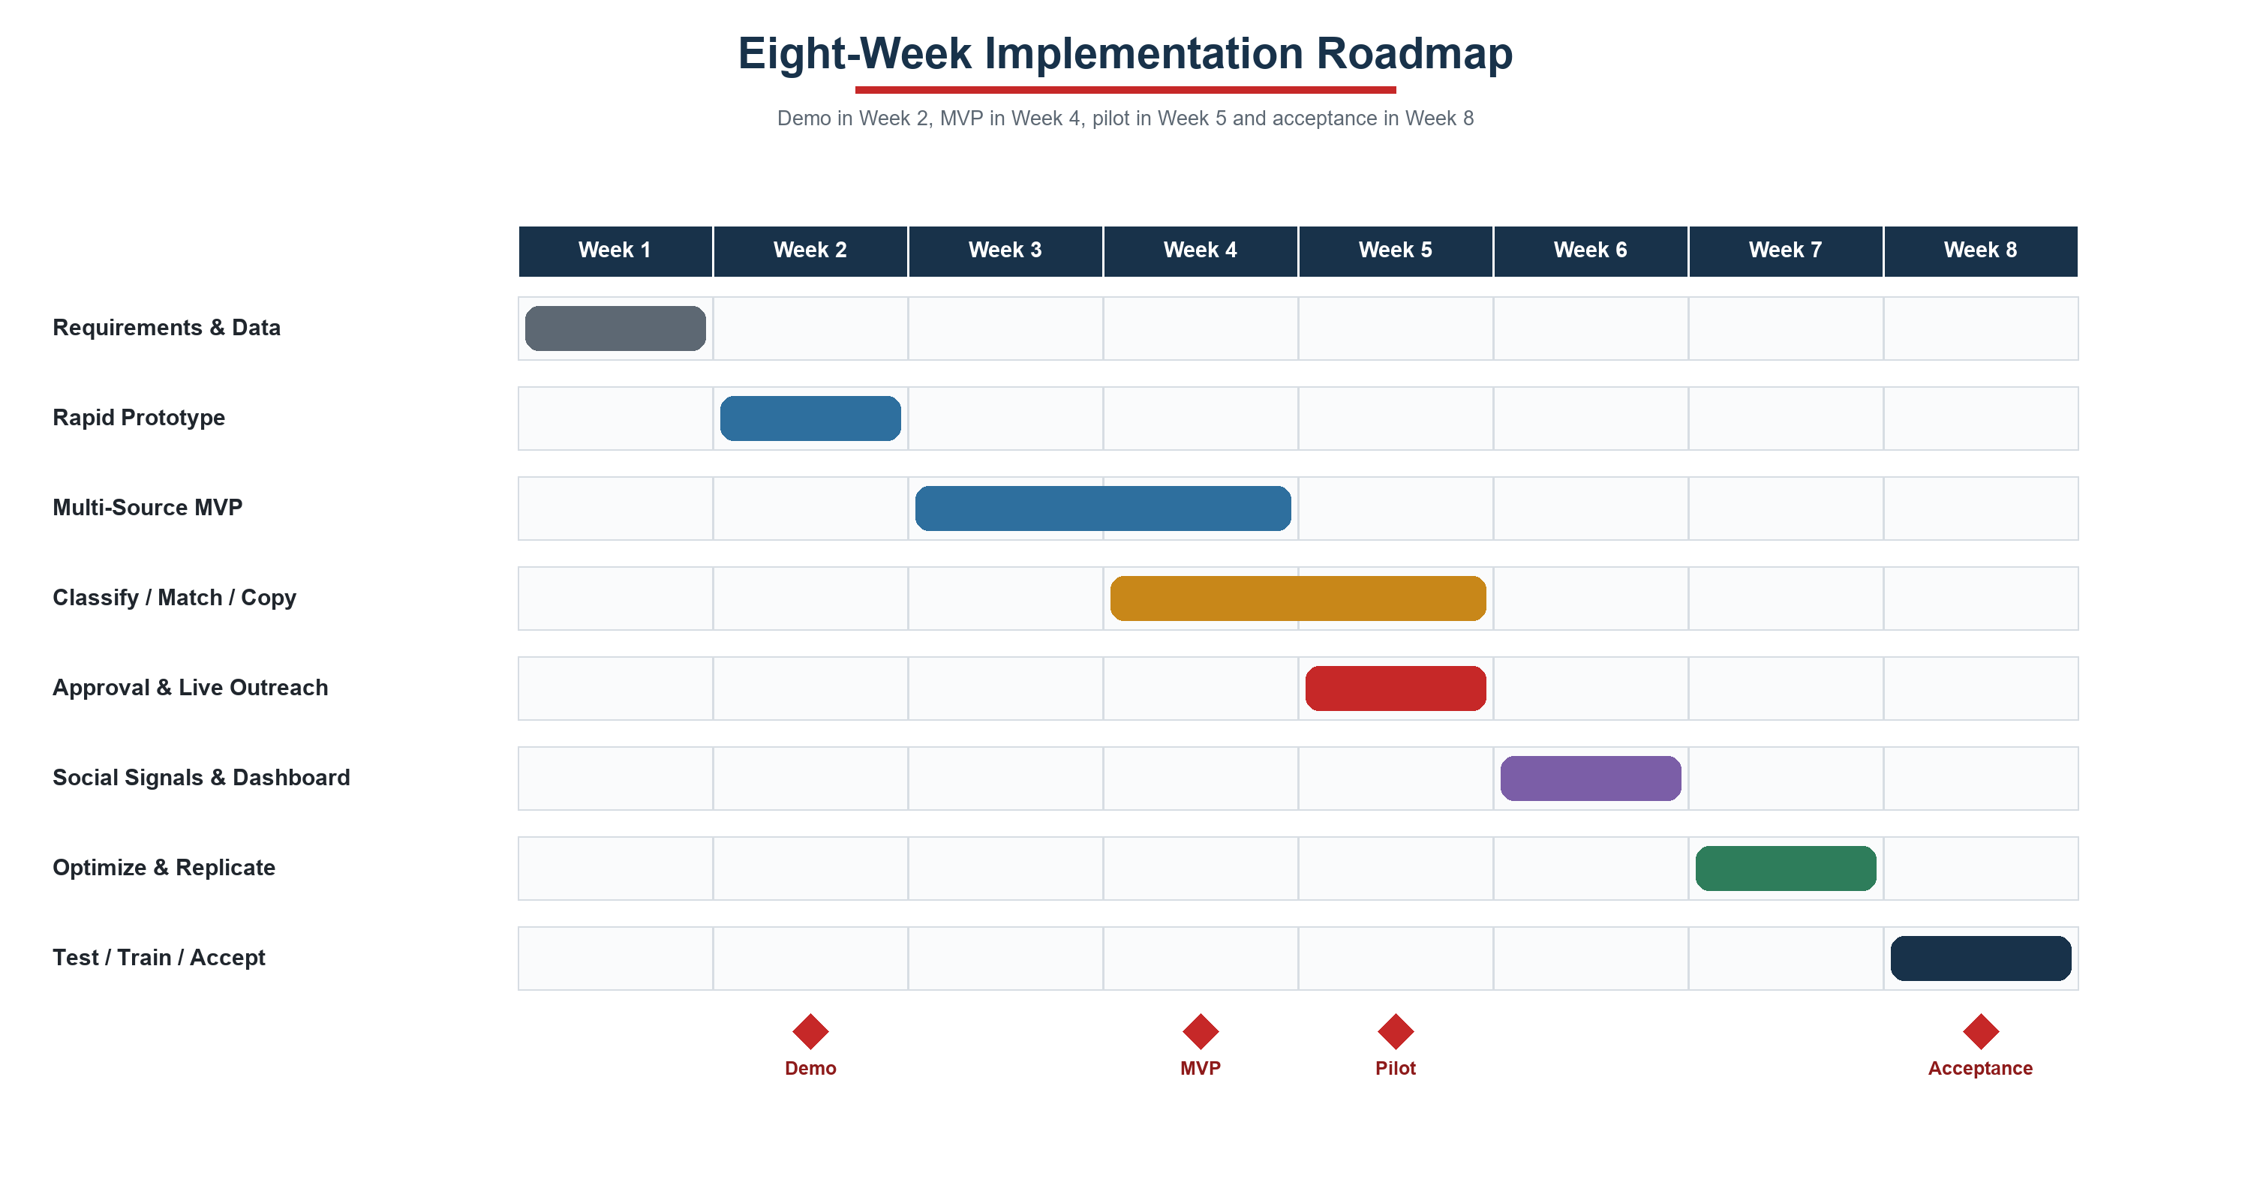
Figure 5. Eight-Week Implementation Roadmap
Milestones provide management with verifiable outcomes in Weeks 2, 4, 5 and 8 instead of deferring all value to project close.

9. Automation Roadmap
Stage | Timing | Automation Scope | Controls Retained
Initial | Within 8 weeks | Automated search, normalization, scoring, matching and outreach drafting | Human approval for all sends; human confirmation for price, contract and delivery
Stage 2 | 4–6 weeks after acceptance | Automated first-touch for 85+ leads, scheduled follow-up, catalogue delivery and reply routing | Daily caps, opt-out, bounce and exception stops
Stage 3 | 6–8 weeks after stable operation | Additional markets, categories, social enquiries and scoring optimization | Approval remains for quotations, payment, contracts and material commitments

10. Acceptance Metrics and Risk Controls
Metric | Target
Required-field completeness | ≥90%
Duplicate rate | <2%
Tier A sampled precision | ≥80%
Hard-bounce rate | <5%
Source traceability | 100%
Initial-phase send approval | 100%
Manual research time reduction | ≥60%

10.1 关键风险控制
- Platform constraints: prioritize official APIs, authorized exports and public business data; create human sales tasks where automated messaging is unavailable.
- Data quality: retain source, capture time, verification status and score reasons; duplicates and stale records do not enter outreach.
- Content accuracy: outbound copy references only approved company knowledge and product master data; missing specifications are not invented.
- Send governance: enforce suppression lists, hard-bounce stops, daily caps, domain-reputation monitoring and manual takeover.
- Commercial commitments: quotations, payment, contracts, certifications and delivery commitments always require business confirmation.
- Access security: apply credential segregation, least privilege, activity logging and periodic retention review.

Appendix A: HR Data Coordination Checklist
- Nominate data owners across management, sales, export operations, product, supply chain, finance and IT
- Provide sample Customers_Orders, Leads_Funnel, Product_Master and Systems_Channels workbooks
- Provide Sales_Messages_FAQ documentation and product image/video folders
- Confirm field definitions, currencies, date formats, null-value meanings and update frequency
- Establish corporate account authorization without transferring personal passwords in spreadsheets
- Confirm owners for retention, opt-out, approval and lead assignment

Appendix B: Core Data Fields
Record | Core Fields
LeadRecord | Company, country, website, source, buyer type, buying evidence, contact, work email, language, score, stage, owner and opt-out
ProductRecord | SKU, category, material, size, MOQ, price tier, Incoterm, sample, lead time, capacity, packing, certification and assets
InteractionRecord | Lead ID, channel, time, direction, template, campaign, opens, clicks, replies, bounces, intent and disposition
CampaignRecord | Market, ICP, products, channel, keywords, copy version, send cap, leads, replies, quotations and conversions

Appendix C: References
- DPV International. Corporate website and product catalogue. https://dpvinternational.com/
- n8n Documentation. Workflow automation and AI integrations. https://docs.n8n.io/
- Google for Developers. YouTube Data API. https://developers.google.com/youtube/v3/docs
- LinkedIn Help. Accessing LinkedIn APIs. https://www.linkedin.com/help/linkedin/answer/a526048
- Meta. WhatsApp Cloud API documentation. https://www.postman.com/meta/whatsapp-business-platform/documentation/wlk6lh4/whatsapp-cloud-api

